They gave an example with the VAT SE**5562825025**01, but considering only the numbers highlighted in yellow.

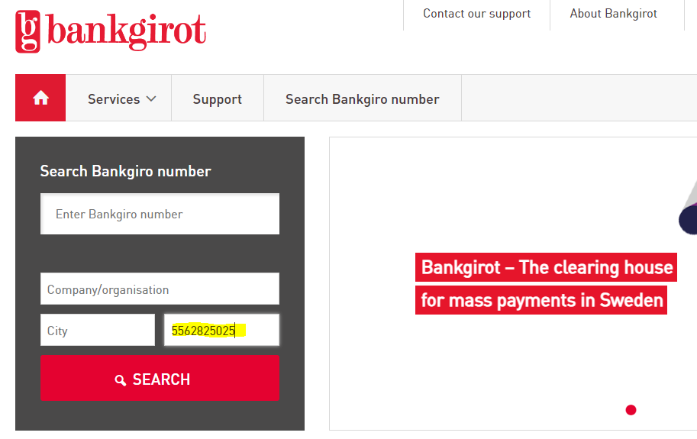

The result is the following:

From here, they can see the vendor's name and address. The Organization number (VAT number without the two first and last digits), and the vendor might indicate one or the other Bankgirot number to create the bank account.

If they search by name without the VAT number, they have this result:

Their Team in Sweden explained that the last two digits is always "01", but the organization number is highlighted in SE**5562825025**01, without the "SE".

For creation of the bank account, they will consider the "Bank Giro Number".

In order to support Business, theay would like to use Bankgiro the same way like to VIES portal, as an additional data source, to show the basic information about the company like NAME, ADDRESS, and VAT#.